Assignment Questions
Note: -
1. The tables mentioned in the questions for the references are available in the classic model database.
2. In the questions, if they specifically mention to create the tables, then you need to create the tables as per given specifications.
3. Solve all the assignment questions, organized by topic wise, within a single query tab only. Kindly submit your MySQL assignments in a single file, using a format that suits you best, such as a .sql file, Notepad, or Word document.
Q1. SELECT clause with WHERE, AND, DISTINCT, Wild Card (LIKE)

- Fetch the employee number, first name and last name of those employees who are working as Sales Rep reporting to employee with employeenumber 1102 (Refer employee table)
Query:-

USE classicmodels;

SELECT employeeNumber,
firstName,
lastName
FROM employees
WHERE jobTitle = 'Sales Rep'
AND reportsTo = 1102;
Expected output:
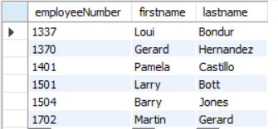

- Show the unique productline values containing the word cars at the end from the products table.
Query:-
USE classicmodels;

SELECT DISTINCT productLine
FROM products
WHERE productLine LIKE '%Cars';
Expected output:
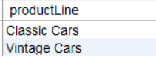

Q2. CASE STATEMENTS for Segmentation

. a. Using a CASE statement, segment customers into three categories based on their country:(Refer Customers table)
"North America" for customers from USA or Canada
"Europe" for customers from UK, France, or Germany
"Other" for all remaining countries
Select the customerNumber, customerName, and the assigned region as "CustomerSegment".
Query:-
USE classicmodels;

SELECT customerNumber,
customerName,
CASE
WHEN country IN ('USA', 'Canada') THEN 'North America'
WHEN country IN ('UK', 'France', 'Germany') THEN 'Europe'
ELSE 'Other'
END AS CustomerSegment
FROM customers;

Expected output:
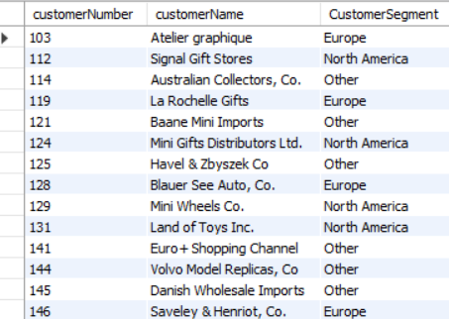

Q3. Group By with Aggregation functions and Having clause, Date and Time functions

- Using the OrderDetails table, identify the top 10 products (by productCode) with the highest total order quantity across all orders.
Query:-
USE classicmodels;

SELECT productCode,
SUM(quantityOrdered) AS total_ordered
FROM orderdetails
GROUP BY productCode
ORDER BY total_ordered DESC
LIMIT 10;

Expected output:
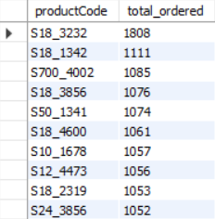

- Company wants to analyse payment frequency by month. Extract the month name from the payment date to count the total number of payments for each month and include only those months with a payment count exceeding 20. Sort the results by total number of payments in descending order. (Refer Payments table).

Query:-
USE classicmodels;

SELECT MONTHNAME(paymentDate) AS payment_month,
COUNT(*) AS num_payments
FROM payments
GROUP BY MONTHNAME(paymentDate)
HAVING COUNT(*) > 20
ORDER BY num_payments DESC;
Expected output:
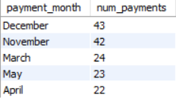

Q4. CONSTRAINTS: Primary, key, foreign key, Unique, check, not null, default

Create a new database named and Customers_Orders and add the following tables as per the description

- Create a table named Customers to store customer information. Include the following columns:

customer_id: This should be an integer set as the PRIMARY KEY and AUTO_INCREMENT.
first_name: This should be a VARCHAR(50) to store the customer's first name.
last_name: This should be a VARCHAR(50) to store the customer's last name.
email: This should be a VARCHAR(255) set as UNIQUE to ensure no duplicate email addresses exist.
phone_number: This can be a VARCHAR(20) to allow for different phone number formats.

Add a NOT NULL constraint to the first_name and last_name columns to ensure they always have a value.
Query:-
CREATE DATABASE Customers_Orders;

USE Customers_Orders;

CREATE TABLE Customers
(
customer_id INT AUTO_INCREMENT PRIMARY KEY,
first_name VARCHAR(50) NOT NULL,
last_name VARCHAR(50) NOT NULL,
email VARCHAR(255) UNIQUE,
phone_number VARCHAR(20)
);

- Create a table named Orders to store information about customer orders. Include the following columns:

order_id: This should be an integer set as the PRIMARY KEY and AUTO_INCREMENT.
customer_id: This should be an integer referencing the customer_id in the Customers table (FOREIGN KEY).
order_date: This should be a DATE data type to store the order date.
total_amount: This should be a DECIMAL(10,2) to store the total order amount.

Constraints:
- Set a FOREIGN KEY constraint on customer_id to reference the Customers table.
- Add a CHECK constraint to ensure the total_amount is always a positive value.
Query:-
USE Customers_Orders;

CREATE TABLE Orders
(
order_id INT AUTO_INCREMENT PRIMARY KEY,
customer_id INT,
order_date DATE,
total_amount DECIMAL(10,2),

CONSTRAINT fk_customer
FOREIGN KEY (customer_id)
REFERENCES Customers(customer_id),

CONSTRAINT chk_total_amount
CHECK (total_amount > 0)
);

Q5. JOINS
a. List the top 5 countries (by order count) that Classic Models ships to. (Use the Customers and Orders tables)
Query:-
USE classicmodels;

SELECT customers.country,
COUNT(orders.orderNumber) AS order_count
FROM customers
INNER JOIN orders
ON customers.customerNumber = orders.customerNumber
GROUP BY customers.country
ORDER BY order_count DESC
LIMIT 5;

Expected output:

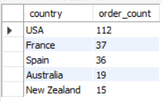

Q6. SELF JOIN
a. Create a table project with below fields.

- EmployeeID : integer set as the PRIMARY KEY and AUTO_INCREMENT.
- FullName: varchar(50) with no null values
- Gender : Values should be only ‘Male’ or ‘Female’
- ManagerID: integer
Add below data into it.
Query:-
USE Customers_Orders;

CREATE TABLE project
(
EmployeeID INT AUTO_INCREMENT PRIMARY KEY,
FullName VARCHAR(50) NOT NULL,
Gender VARCHAR(10) CHECK (Gender IN ('Male','Female')),
ManagerID INT
);

INSERT INTO project
(EmployeeID, FullName, Gender, ManagerID)
VALUES
(1,'Pranaya','Male',3),
(2,'Priyanka','Female',1),
(3,'Preety','Female',NULL),
(4,'Anurag','Male',1),
(5,'Sambit','Male',1),
(6,'Rajesh','Male',3),
(7,'Hina','Female',3);

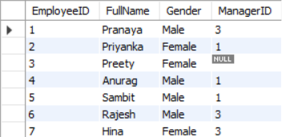
Find out the names of employees and their related managers.
Query:-

SELECT
M.FullName AS 'Manager Name',
E.FullName AS 'Emp Name'
FROM project E
INNER JOIN project M
ON E.ManagerID = M.EmployeeID;

Expected output:
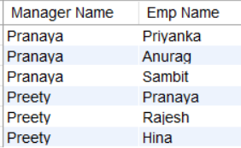

Q7. DDL Commands: Create, Alter, Rename
a. Create table facility. Add the below fields into it.
- Facility_ID
- Name
- State
- Country

i) Alter the table by adding the primary key and auto increment to Facility_ID column.
ii) Add a new column city after name with data type as varchar which should not accept any null values.
Query:-

USE Customers_Orders;

CREATE TABLE facility
(
Facility_ID INT,
Name VARCHAR(100),
State VARCHAR(100),
Country VARCHAR(100)
);

ALTER TABLE facility
MODIFY Facility_ID INT AUTO_INCREMENT,
ADD PRIMARY KEY (Facility_ID);

ALTER TABLE facility
ADD City VARCHAR(100) NOT NULL
AFTER Name;

DESCRIBE facility;

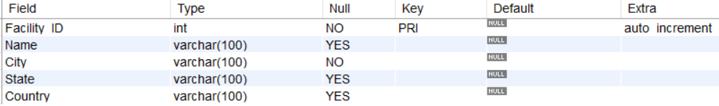

Q8. Views in SQL
a. Create a view named product_category_sales that provides insights into sales performance by product category. This view should include the following information:
productLine: The category name of the product (from the ProductLines table).

total_sales: The total revenue generated by products within that category (calculated by summing the orderDetails.quantity * orderDetails.priceEach for each product in the category).

number_of_orders: The total number of orders containing products from that category.

(Hint: Tables to be used: Products, orders, orderdetails and productlines)
Query:-

USE classicmodels;

CREATE VIEW product_category_sales AS
SELECT
p.productLine,
SUM(od.quantityOrdered * od.priceEach) AS total_sales,
COUNT(DISTINCT o.orderNumber) AS number_of_orders
FROM productlines pl
INNER JOIN products p
ON pl.productLine = p.productLine
INNER JOIN orderdetails od
ON p.productCode = od.productCode
INNER JOIN orders o
ON od.orderNumber = o.orderNumber
GROUP BY p.productLine;

SELECT * FROM product_category_sales;

The view when read should show the output as:

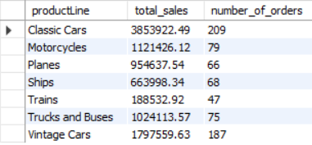

Q9. Stored Procedures in SQL with parameters

a. Create a stored procedure Get_country_payments which takes in year and country as inputs and gives year wise, country wise total amount as an output. Format the total amount to nearest thousand unit (K)
Tables: Customers, Payments
Query:-

USE classicmodels;

DELIMITER //

CREATE PROCEDURE Get_country_payments
(
IN p_year INT,
IN p_country VARCHAR(50)
)
BEGIN

SELECT
YEAR(paymentDate) AS Year,
c.country,
CONCAT(ROUND(SUM(amount)/1000),'K') AS TotalAmount
FROM customers c
INNER JOIN payments p
ON c.customerNumber = p.customerNumber
WHERE YEAR(paymentDate)=p_year
AND country=p_country
GROUP BY YEAR(paymentDate),country;

END //

DELIMITER ;

CALL Get_country_payments(2003,'France');
Expected output:

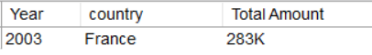

Q10. Window functions - Rank, dense_rank, lead and lag

- Using customers and orders tables, rank the customers based on their order frequency

Query:-

USE classicmodels;

SELECT
c.customerName,
COUNT(o.orderNumber) AS Order_count,
RANK() OVER (ORDER BY COUNT(o.orderNumber) DESC) AS order_frequency_rnk
FROM customers c
INNER JOIN orders o
ON c.customerNumber = o.customerNumber
GROUP BY c.customerNumber, c.customerName;

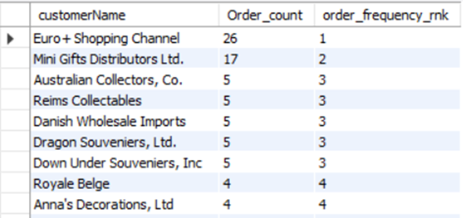

b) Calculate year wise, month name wise count of orders and year over year (YoY) percentage change. Format the YoY values in no decimals and show in % sign.
Table: Orders
Query:-
USE classicmodels;

WITH MonthlyOrders AS
(
SELECT
YEAR(orderDate) AS Year,
MONTH(orderDate) AS MonthNo,
MONTHNAME(orderDate) AS Month,
COUNT(orderNumber) AS TotalOrders
FROM orders
GROUP BY YEAR(orderDate),
MONTH(orderDate),
MONTHNAME(orderDate)
)

SELECT
Year,
Month,
TotalOrders,
CASE
WHEN LAG(TotalOrders) OVER (ORDER BY Year, MonthNo) IS NULL
THEN NULL
ELSE CONCAT(
ROUND(
(
(TotalOrders - LAG(TotalOrders) OVER (ORDER BY Year, MonthNo))
/ LAG(TotalOrders) OVER (ORDER BY Year, MonthNo)
) * 100,
0
),
'%'
)
END AS `% YoY Change`
FROM MonthlyOrders
ORDER BY Year, MonthNo;
Expected output:
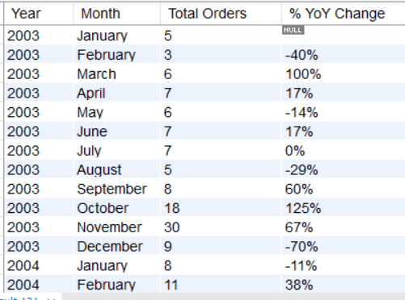

Q11.Subqueries and their applications

a. Find out how many product lines are there for which the buy price value is greater than the average of buy price value. Show the output as product line and its count.
Query:-
USE classicmodels;

SELECT
productLine,
COUNT(*) AS Total
FROM products
WHERE buyPrice >
(
SELECT AVG(buyPrice)
FROM products
)
GROUP BY productLine
ORDER BY Total DESC;
Expected output:
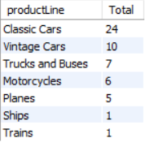

Q12. ERROR HANDLING in SQL
Create the table Emp_EH. Below are its fields.
- EmpID (Primary Key)
- EmpName
- EmailAddress
Create a procedure to accept the values for the columns in Emp_EH. Handle the error using exception handling concept. Show the message as “Error occurred” in case of anything wrong.
Query:-

USE Customers_Orders;

CREATE TABLE Emp_EH
(
EmpID INT PRIMARY KEY,
EmpName VARCHAR(100),
EmailAddress VARCHAR(100)
);

DELIMITER //

CREATE PROCEDURE Insert_Emp_EH
(
IN p_EmpID INT,
IN p_EmpName VARCHAR(100),
IN p_EmailAddress VARCHAR(100)
)
BEGIN

DECLARE EXIT HANDLER FOR SQLEXCEPTION
BEGIN
SELECT 'Error occurred' AS Message;
END;

INSERT INTO Emp_EH
VALUES
(
p_EmpID,
p_EmpName,
p_EmailAddress
);

END //

DELIMITER ;

CALL Insert_Emp_EH(1,'Amit','amit@gmail.com');

CALL Insert_Emp_EH(1,'Rahul','rahul@gmail.com');

SELECT * FROM Emp_EH;

Q13. TRIGGERS
Create the table Emp_BIT. Add below fields in it.
- Name
- Occupation
- Working_date
- Working_hours

Insert the data as shown in below query.
INSERT INTO Emp_BIT VALUES
('Robin', 'Scientist', '2020-10-04', 12),
('Warner', 'Engineer', '2020-10-04', 10),
('Peter', 'Actor', '2020-10-04', 13),
('Marco', 'Doctor', '2020-10-04', 14),
('Brayden', 'Teacher', '2020-10-04', 12),
('Antonio', 'Business', '2020-10-04', 11);

Create before insert trigger to make sure any new value of Working_hours, if it is negative, then it should be inserted as positive.

Query:-
USE Customers_Orders;

CREATE TABLE Emp_BIT
(
Name VARCHAR(100),
Occupation VARCHAR(100),
Working_date DATE,
Working_hours INT
);

DELIMITER //

CREATE TRIGGER trg_before_insert_emp
BEFORE INSERT
ON Emp_BIT
FOR EACH ROW
BEGIN
IF NEW.Working_hours < 0 THEN
SET NEW.Working_hours = -NEW.Working_hours;
END IF;
END //

DELIMITER ;

INSERT INTO Emp_BIT VALUES
('Robin', 'Scientist', '2020-10-04', 12),
('Warner', 'Engineer', '2020-10-04', 10),
('Peter', 'Actor', '2020-10-04', 13),
('Marco', 'Doctor', '2020-10-04', 14),
('Brayden', 'Teacher', '2020-10-04', 12),
('Antonio', 'Business', '2020-10-04', 11);

-- Test the trigger
INSERT INTO Emp_BIT
VALUES
('Amit','Developer','2026-07-13',-8);

SELECT * FROM Emp_BIT;

